**HOW** **TO** **CREATE** **A** **LAN** **NETWORK** **BETWEEN** **TWO** **PC’S**.

**Introduction**.

LAN (local area network) is the connection of devices found in a relatively small area e.g. our homes offices and even schools so as to make information circulate faster and easier.

**Using the Cisco Packet Tracer.**

We use the cisco packet tracer for the visual connection between pc’s and other devices. It shows the setup of connections between devices. The steps involved in these connections include;

* Step 1: Here, after opening the packet tracer, we take the pc icons by clicking on the end device which is located at the bottom left of our page. After we click this end device we see under sets of other icons, then we click the end device. Click the pc icon the place on the logical work space.
* Step 2: We use the copper cross over to connect the 2 PC’s.
* Step 3: Here we are to configure the PC’s by assigning IP addresses to them. To do that we click on the each PC, go to desktop, then click on IP configuration making sure the setting is on static so as to assign its IP address.
* Step 4: we check to see if both of the computers are well connected by running a command prompt making sure there are no losses (loss 0%).

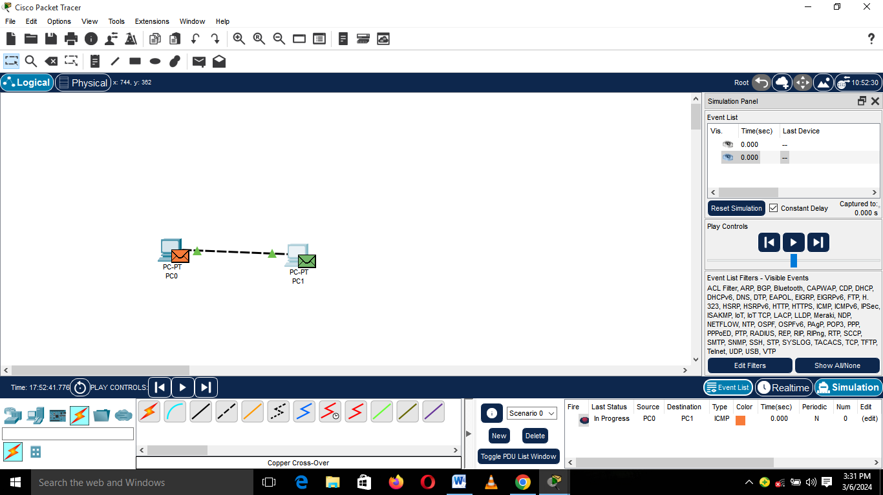

**Real Life Deployment**.

Here we start implying what we had done in the packet tracer in real life. The steps involve;

* Step 1: connecting the two pcs with a LAN cable(rg45 ethernet cable)
* Step 2: We go to our network setting click on Ethernet and then take Network and sharing. The we get to see a page as shown below and click on Ethernet.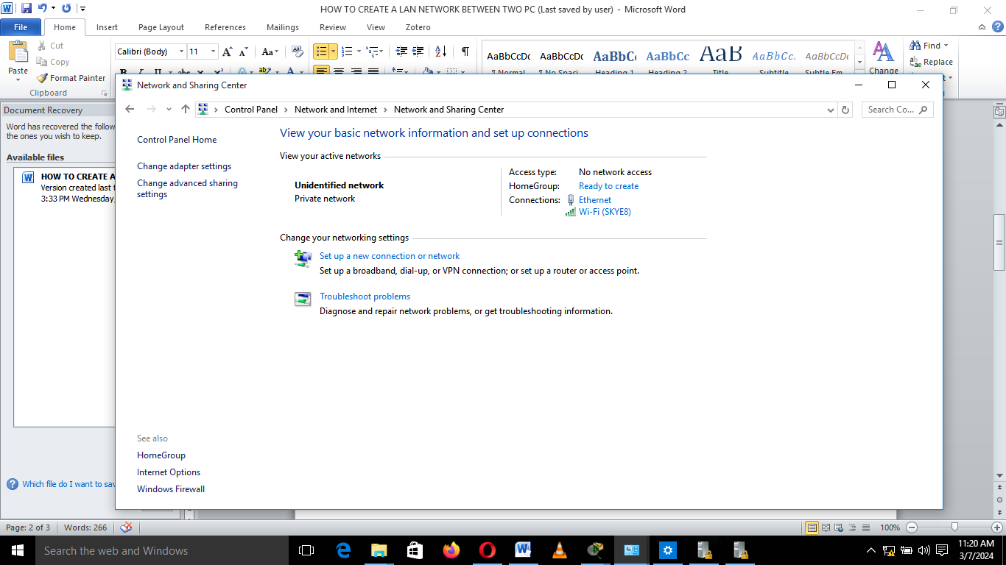

There we get to assign an IP address to the computer under the IP version 4.

* Step 3: Here we make our computer’s network to private using local security policies.
* Step 4: We choose the document which we want to make available to the other pc and then set in a way which will be available to everyone.